**Territorial Acquisition**

For this project, I was put into a group with Alexander Lawton and Jamie Soden, who I had never worked with before.

The game we decided to design was based around the Battle of Britonia between Mercia, Northumbria, Wessex and The Vikings and emulates a battle between the 4 factions by acquiring territory by “battling” other factions. The premise of the game is to acquire as much territory as possible from the other factions, while defending your own territory.

The game has very basic rules, in the game we designed, to capture territory you must be directly adjacent to the tile you want to capture, meaning you cannot capture territory diagonally. To capture open tiles, you need to roll a die and roll 3 or higher. To take territory from another player you need roll dice and get a higher number than the defender, however if you roll equal, the defender keeps the territory. There are special spaces that require the player the roll 5 or higher to capture, however they give a +1 bonus to the players rolls when defending any territory they own, which increases depending on the number of special spaces they own with a max of +5, as that is the number of special spaces.

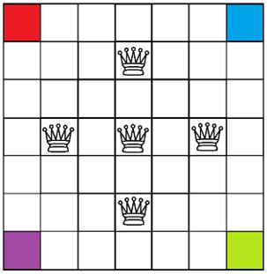The game is played with a maximum of 4 players and is turn based, meaning that each player takes turns to do what actions they want but they can only do one action per turn. The current player has to decide which adjacent tile they want to capture, and if its unclaimed they have to roll a die and can only acquire the territory if they roll a number 3 or higher or if the space is classified as a special space, they have to roll 5 or higher, however if they decide to “invade” a territory that is owned by a different player, the defender also has to roll a die to see what defence value they have. There are 20 turns per player in the game and the player must decide whether to claim as many unclaimed tiles or invade the players to try and take tiles from other players.



We were not able to get other groups to playtest our game, however we internally tested many of the main gameplay variables such as grid size and player turns. We originally started off with a large grid size of between 9x9 to 11x11, we realised that this would mean that players would have barely have any player vs player conflict, so we decreased it to 7x7. We also started off with a lower number of turns of around 10-12, but we realized how little gameplay there would be, so we increased it to 20, however in my opinion this is still a bit too low, I would recommend turns in the 40s to 50s and make the grid size something around 13x13.

Arrows Represent the directions players can invade.

The 4 colours represent the 4 factions; however, the colours are placeholder and were meant to be the flags of the 4 factions.

In the team, we all had very similar ideas to start with, so we had to compare and conclude on gameplay and mechanics. We had to options at the start, either a tile-based game using die and a tile-based game using cards. In the card idea, players were given cards that represented units such as bowmen and catapults, however we realised how luck based this could be as players could get all the best cards and hoard them, so we settled on the die version. Throughout the whole project, we all had very similar ideas to improve the whole design of the project so there was not much conflict on any parts of the design.

